***The Lucky 13!***

***WHY “R” THEY LUCKY?***

***BECAUSE NOW YOU KNOW WHAT MISTAKES NOT TO MAKE!***

13. (NO CALCULATOR) Scientists were attempting to determine the number of goldfish in a pond. On day 4 there were 50 fish in the pond. The growth rate fish in the pond is modeled by the equation  where “t” represents days. Determine how many fish were in the pond at the end of the 9th day. You can leave your answers in terms of “e”.

12. 

11. Find the following integrals: 

10. Evaluate each of the following



****9. The graph to the right is the

graph of  the derivative of .

Where is concave down? Justify

your answer.

8. Write the equation for y in terms of x given that 

7. Find both the average rate of change and the average value 

6. Given that , [0,4] find the x-coordinate of all relative minimums and maximums. What is the absolute maximum value? Justify your answer.

5. What is the x coordinates of all points of inflection?



4. 

Find 

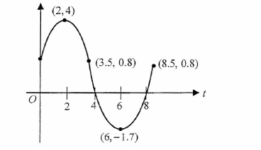

3.

The graph of a differentiable function f is shown above. If  which of the following is true?



2. Using the substitution , rewrite the following integral in terms of u



1. When is the velocity increasing and when is the SPEED INCREASING!!!

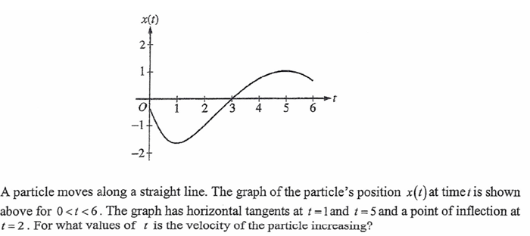

0.  Evaluate the following: 

IMPORTANT NOTES:

**1. WHEN YOU ARE DOING INTEGRALS, PUT THE EQUATIONS IN**

** DO NOT PUT EQUATIONS IN YOUR INTEGRAL.**

**2. BALD ANSWERS**

**3. RADIAN MODE**

**4. MAKE SURE TO SHOW ALL INTEGRALS.**

**5. SEPARATION OF VARIABLES…. THE “C”**